2025 PIONEER DAY PARADE

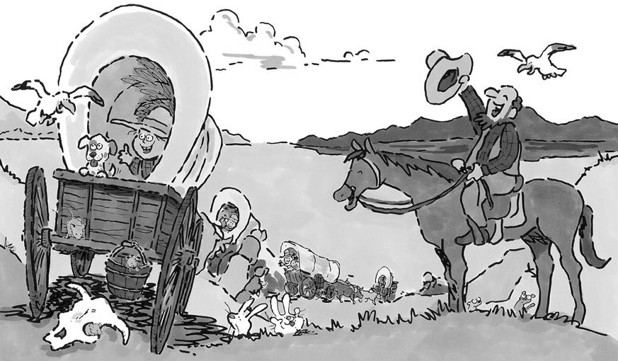Saturday,

October 5th

2:30 p.m.

Hosted by

Lake Whitney

Chamber of Commerce

Theme:

**DEADLINE**: *Parade Packet due by September 30th, 4 pm.*

Please check one of the following divisions that your group will be participating in:

Float Entry ____ Car Entry ____ Walking Group ____ Horse Group ____ Band Entry ____

Miscellaneous (Bicycle, Golf Cart, etc.) ___________________________________________

Name of Organization/Business: ______________________________________________________

Contact Name: _____________________________________________________________

Street Address: _____________________________________________________________

City: ________________________________ State: ________________ Zip: ____________

Home/Work Phone: _______________________ Cell Phone: ________________________

E-mail Address: ____________________________________________________________

Number of people in group: ____________

1:30 p.m. - Lineup at the Intermediate School Parking Lot at South San Jacinto & Roberts Rd.

2:30 p.m. - Parade begins

Forms may be submitted by:

Email: info@lakewhitneychamber.com

Mail: Lake Whitney Chamber of Commerce, P.O. Box 604, Whitney, TX 76692

Drop Off at: Chamber Office 101 E. Jefferson Ave., Whitney, Tx. 76692

For additional information contact:

Janice Sanders − 254-625-2387

**LIABILITY WAIVER FORM**

Unconditional Waiver of Liability

I (print your name) ______________________________________

representing (print name of company/organization) _______________________________________

Recognize the efforts of the organizers, directors, and staff of the Lake Whitney Chamber of Commerce, to put on its annual Pioneer Day Parade to be held on October 1, 2022. I also recognize that participation in said parade includes inherent risks of injury or damage to me and to others. I further recognize and acknowledge the efforts of said organizers, officers, directors and staff to obtain full coverage for all riders and participants in said parade, acknowledging their inability to obtain such blanket insurance coverage at reasonable affordable prices. Therefore, in return for the privilege of participating in the Pioneer Day Parade, I hereby give this, my unconditional waiver of liability and hold harmless agreement, to and in favor of the Lake Whitney Chamber of Commerce, together with all of its organizers, officers, directors and staff.

By this act, I agree forever to release the Lake Whitney Chamber of Commerce and all its organizers, officers, directors and staff from any and all liability for any injury or harm I or any members of said organization including any minor child may suffer as a result of participation in said parade or activities preparatory or subsequent thereto. This act shall bind me, as well as my heirs, family and assigns.

This waiver and hold harmless shall apply in favor of the Lake Whitney Chamber of Commerce and all its organizers, officers, directors and staff, regardless whose act, fault or negligence shall have led to any such injury, harm or damage. Furthermore, this waiver and hold harmless shall apply in favor of the Lake Whitney Chamber of Commerce and all its organizers, officers, directors and staff, regardless of who might institute and claim or action arising from said parade or activities preparatory or subsequent thereto.

______________________________________ __________________________

Signature of Participant Date

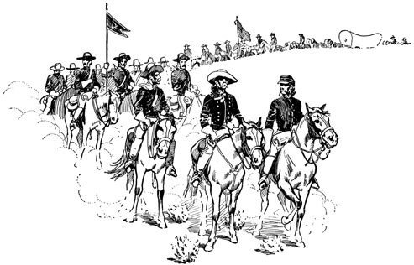

PIONEER DAY

PARADE RULES:

1. A signed Release and Hold Harmless Agreement must be signed.

2. No registrations will be accepted after 4:00 p.m. on September 30th, 4 pm

3. No alcoholic beverages are permitted. No vulgarity will be permitted. Participants and entries in the parade are not allowed to have or be under the influence of alcohol or drugs.

4. Tow and trailer length not to exceed 35 feet without written permission from parade officials.

5. When throwing candy - no damaging materials, projectiles or profane materials will be permitted.

6. It is required that a minimum of two walkers, one on either side must accompany each entry during the entire parade route as protection for your group and vehicle/float, and to prevent injury to people lining the streets. The kids running out in front of vehicles to get candy almost caused an accident last year.

7. Parade entries are expected to arrive for line up at the Intermediate School parking lot beginning at 1:30 p.m.

The parade will leave the school at 2:30 p.m.

8. We estimate that the entire parade route will take approximately one hour.

9. Parade Chair will place you in the order the committee has agreed upon which all entries must abide by.

10. If you want your entry to be announced by the Parade Committee, we MUST have your entry by Sept 30.

11. Parade Coordinators reserve the right to remove your entry from this parade for not abiding by the rules outlined above.

Janice Sanders, Executive Director

**Lake Whitney Chamber of Commerce ⋅ 101 E. Jefferson Ave. ⋅ P.O. Box 604 ⋅ 254-694-625-2387**

[www.lakewhitneychamber.com](http://www.lakewhitneychamber.com) E-mail: [info@lakewhitneychamber.com](mailto:info@lakewhitneychamber.com)